Nada Shabout

734 words

**Selim, Jewad (1921-1961)**

Born in Ankara, Turkey, Jewad Selim descended from an Iraqi family of artists. His father is Hajj Mohammad Selim, his sister Naziha Selim and brothers Suad and Nazar Selim, each an accomplished artist in their own right. One of the most prominent and influential figures in the formation of the Iraqi Modern art movement, Selim was awarded a government scholarships to study sculpture in Paris (1938–39), in Rome (1939–40), and in London at the Slade School of Art (1946–49). In Baghdad, he was a founding member of the first art society in Iraq, the Society of the Friends of Art in 1941, a founding member of the Institute of Fine Arts in 1949, the Baghdad Group of Modern Art in 1951, and the Society of Iraqi Plastic Artists in 1956. He worked at the Baghdad Museum of Antiquities, where he spent several years restoring Sumerian and Assyrian reliefs. His most mature paintings date from the 1950s, after which he concentrated solely on sculpture. He headed the Department of Sculpture at the Institute of Fine Arts until his death. His style inspired the imagination of virtually an entire generation of younger artists and his influence is still evident today. Selim’s work evokes a shared humanity and defines a sense of historical identity and national character, which inspired many Iraqi artists to emulate his artistic methods.

A charming dandy who became a myth after his untimely demise, Selim was a passionate man but an intellectual artist. He was as pragmatic as he was a romantic, and an activist, a cultural agent who professed as his duty to exact change. He was a modern artist whose experimentation with form and content did not end till his death. He was continuously in search of possibilities not answers or solutions. Among his key goals was creating an art educated and appreciative culture, and an audience that would parallel and reflect the social and artistic change of the period.

As the leader of the Bagdad Group of Modern Art, co-founded with artist Shakir Hassan Al Said, Selim emphasized and promoted the notion of “*istilham al-turath*,” which translates to “seeking inspiration and motivation from tradition,” and developed an artistic vision, which was equally historio-cultural and modern. Istilham is a concept that advocates mediation between the past and the present; a form of a negotiation of heritage and tradition, to project forward and realize a new contemporary aesthetic.

Selim’s work fluctuated between the local, such as in his Baghdadiat series that articulated modern life in Baghdad portraying scenes of street and domestic life, and the global, transnational themes like motherhood and the political prisoner. Selim’s Political Prisoner sculpture was one of the 86 works awarded prizes in the world-wide sculpture competition, The Unknown Political Prisoner, organized by The Institute of Contemporary Arts in London in 1952.

Selim’s ideas, exploration and experience culminated in his last masterpiece, which became a landmark of and for Baghdad. *Nasb al-Hurriyah,* Monument of Freedom, commissioned by the new Iraqi military regime in 1959 to celebrate the revolution, and was the first public monument in Iraq to be built by an Iraqi artist. A bas-relief mural in bronze (50m x 8m), its twenty-five connected figures, divided in fourteen bronze units, visually narrates the revolution and the events that surrounded it. Equally the units resemble the letters of an Arabic verse in their movement and flow, combining the linear quality of Arabic characters and stylized forms of Sumerians and Babylonians with modern European styles. The narrative was organized in several interconnected groups, expressing injustice, resistance, solidarity, hope and ambition, and portrayed in a style of symbolic realism. A humanistic composition juxtaposing several familiar concepts in his oeuvre: eternal calamity, motherhood, and fertility. Selim died before it was completed.

**References and Further Reading**

Ali, Wijdan (1997), *Modern Islamic Art: Development and Continuity*. Gainesville: University Press of Florida.

Al Said, Shaker Hassan (1991), *Jewad* *Selim: al-fannaan wa al-a’kharoon* (Jewad Selim: The Artist and the Others*)*, Baghdad: The General House of Cultural Affairs, Ministry of Culture.

Saleem Al-Bahloly (2012), “Jewad Selim,” in Samar Faruqi, ed., *Meem Projects 2012*, Abu Dhabi: The Publications Department of Meem with Art Advisory Associates Ltd, 52-57.

Shabout, Nada (2014), “Whose Space is it?” An International Journal of Middle East Studies (IJMES) roundtable on the production of public space. IJMES 46(1) – February.

*________*(2012), *Forever Now: Five Anecdotes from the Permanent Collection*, Exhibition catalogue, Mathaf: Arab Museum of Modern Art, Doha, Qatar. Doha: Bloomsbury Qatar Foundation Publishing.

________ (2007), *Modern Arab Art: Formation of Aesthetics*, Florida: University Press of Florida.

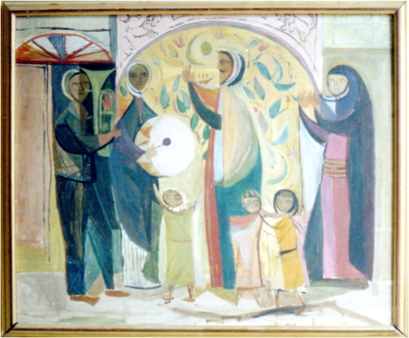

Jewad Selim, *Music in the Street*, 1956

From the looted collection of the Iraqi Museum of Modern Art, Baghdad

Modern Art Iraq Archive, MAIA (artiraq.org). Permission granted.

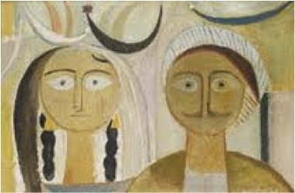

Jewad Selim, *Young Man and Wife, 1953*

Mathaf: Arab Museum of Modern Art

Contact James Strickland, Deputy Director of Collections, at [jstrickland@qm.org.qa](mailto:jstrickland@qm.org.qa) for the permission form and hi res images. They are aware of the request and I do have their permission.